Conversion from RGB to HSV
Let
- 0<=R,G,B<=255.
- M = max(R,G,B)
- m = min(R,G,B)
- C = M-m
Then H, S, V are determined as follows
- 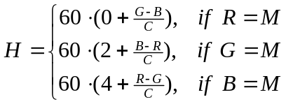
- 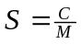
- 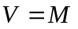
with H = H mod 360. There are two special cases which are set as follows
- If M=0 then S=0 and H=0 (and V=0). This is black.
- If C=0 then H=0 (and S=0). This is grey.
Note that the ranges are as follows
- 0<=H<360.0, 0<=S<=1 and 0<=V<=255.

Conversion from HSV to RGB
The HSV values are modified as follows
- S’ = s*S, H’ = (h+H) mod 360, V’ = vb+vc*V
The corresponding RGB values are determined as follows
- 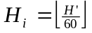
- 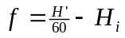
- 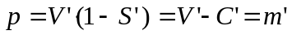
- 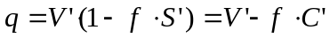
Then it follows that
H_{i} | R | G | B
0 | V’ | t | p
1 | q | V’ | p
2 | p | V’ | t
3 | p | q | V’
4 | t | p | V’
5 | V’ | p | q
Let C’=V’*S’, m’=V’-C’, R1=R-m’, G1=G-m’ and B1=B-m’.
Then it follows that
- (V’-m’)/C’ = 1
- (p-m’)/C’ = 0
- (q-m’)/C’ = (V’-f*C’-m’)/C’ = 1-f
- (t-m’)/C’ = (V’-(1-f)*C’-m’)/C’ = f
H_{i} | R1/C’ | G1/C’ | B1/C’
0 | 1 | f | 0
1 | 1-f | 1 | 0
2 | 0 | 1 | f
3 | 0 | 1-f | 1
4 | f | 0 | 1
5 | 1 | 0 | 1-f
Note that
H’/60 = int(H'/60) + H’/60 mod 1
and thus
f = H’/60 – int(H’/60) = H’/60 mod 1 = H’’ mod 1 , where H’’=H’/60
Finally
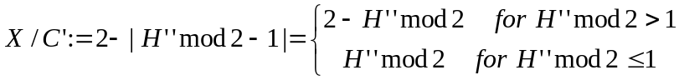
thus
It follows that
H_{i} | R1/C’ | G1/C’ | B1/C’
0 | 1 | X | 0
1 | X | 1 | 0
2 | 0 | 1 | X
3 | 0 | X | 1
4 | X | 0 | 1
5 | 1 | 0 | X
Note that if S’=0, it follows that R=G=B=V’ (being grey).

Conversion from RGB to HSL
Let
- 0<=R,G,B<=255.
- M = max(R,G,B)
- m = min(R,G,B)
- C = M-m
Then H, S, L are determined as follows
- 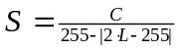
- 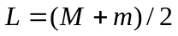
with H = H mod 360. There are two special cases which are set as follows
- If L=0 or L=1 then S=0 and H=0. This is black.
- If C=0 then H=0 (and S=0). This is grey.
Note that the ranges are as follows
- 0<=H<360.0, 0<=S<=1 and 0<=L<=255.

Conversion from HSL to RGB
The HSV values are modified as follows
- S’ = s*S, H’ = (h+H) mod 360, L’ = vb+vc*L
The corresponding RGB values are determined as follows

Let C’=(255-|255-2*L’|)*S’, m’=L’-C’/2, R1=R-m’, G1=G-m’ and B1=B-m’.
Then it follows that
H_{i} | R1/C’ | G1/C’ | B1/C’
0 | 1 | f | 0
1 | 1-f | 1 | 0
2 | 0 | 1 | f
3 | 0 | 1-f | 1
4 | f | 0 | 1
5 | 1 | 0 | 1-f
Note that
H’/60 = int(H'/60) + H’/60 mod 1
and thus
f = H’/60 – int(H’/60) = H’/60 mod 1 = H’’ mod 1 , where H’’=H’/60
Finally
thus
It follows that
H_{i} | R1/C’ | G1/C’ | B1/C’
0 | 1 | X | 0
1 | X | 1 | 0
2 | 0 | 1 | X
3 | 0 | X | 1
4 | X | 0 | 1
5 | 1 | 0 | X

Note that if S’=0, it follows that R=G=B=L’ (being grey).

Conversion from RGB to HSI
Let
- 0<=R,G,B<=255.
- M = max(R,G,B)
- m = min(R,G,B)
- med = R+G+B-M-m
Then H, S, V are determined as follows
- 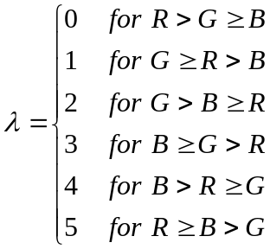
- 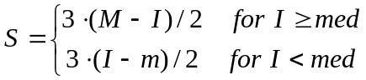
- 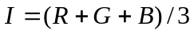
- 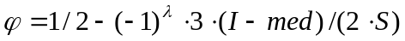 (with 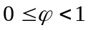)
- 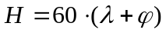
with H = H mod 360. There is one special case which is set as follows
- If M=I or m=I then R=G=B and thus S=0. Then H=0. This is grey.
Note that the ranges are as follows
- 0<=H<360.0, 0<=S<=255 and 0<=I<=255.

Conversion from HSI to RGB
The HSI values are modified as follows
- S’ = s*S, H’ = (h+H) mod 360, I’ = vb+vc*I
The corresponding RGB values are determined as follows
Let R1=R-I’, G1=G-I’ and B1=B-I’.
Then it follows that for f>=1/2:
H_{i} | R1/S’ | G1/S’ | B1/S’
0 | 1-2f/3 | -1/3+2f/3 | -2/3
1 | -1/3+2f/3 | 1-2f/3 | -2/3
2 | -1/3+2f/3 | -2/3 | 1-2f/3
3 | -2/3 | -1/3+2f/3 | 1-2f/3
4 | -2/3 | 1-2f/3 | -1/3+2f/3
5 | 1-2f/3 | -2/3 | -1/3+2f/3
and for f<1/2:
H_{i} | R1/S’ | G1/S’ | B1/S’
0 | 2/3 | -1/3+2f/3 | -1/3-2f/3
1 | -1/3+2f/3 | 2/3 | -1/3-2f/3
2 | -1/3+2f/3 | -1/3-2f/3 | 2/3
3 | -1/3-2f/3 | -1/3+2f/3 | 2/3
4 | -1/3-2f/3 | 2/3 | -1/3+2f/3
5 | 2/3 | -1/3-2f/3 | -1/3+2f/3
Note that if S’=0, it follows that R=G=B=I’ (being grey).

References
http://nl.wikipedia.org/wiki/HSV_%28kleurruimte%29 (a dutch link about HSV)
http://en.wikipedia.org/wiki/HSL_and_HSV (about HSV and HSL)
Chapitre 3 - Représentations couleur luminance, saturation et teinte (the thesis of Jesus Angulo)
Modelling and segmentation of colour images in polar representations (a paper by Jesus Angulo and Jean Serra)
Espaces couleur adaptes au traitement d'image (a paper by Jean Serra)

